University of Gujrat
Department of Software Engineering
Object Oriented programming (Lab)
Submitted by:
Muhammad Aliyan
25021598-245
Section:
AB
Submitted to:
Ma’am Sameen Gul
Lab 1 3
Count 1 to 4 3
Squares of Numbers and the Sum and Difference of their Squares 4
Sum, Average, Product, Smallest and Largest 5
Check if Number and its Square is Greater Than, Equal To or Lesser than 1000 6
Lab 2 7
Check Positive 7
Pass Check 7
Check Even or Odd 8
Check Leap Year 9
Calculate Electricity Bill 10
Check Largest Number 12
Print Grade 13
Check Leap Year (Specific Conditions) 14
Check Vote Eligibility 15
Perform Arithmetic Operations 16

Lab 1

Count 1 to 4
- Write a program that displays the number 1 to 4 on the same line with each pair of adjacent numbers separated by space using a “System.out.print” Statement.
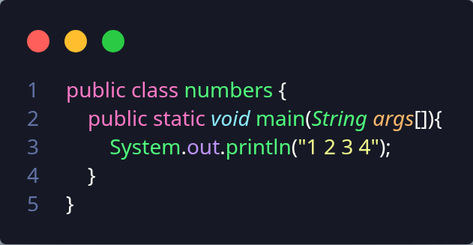

Squares of Numbers and the Sum and Difference of their Squares
- Write a program that asks the user to enter 2 integers and print the square of each, the sum of their square and the difference of their square
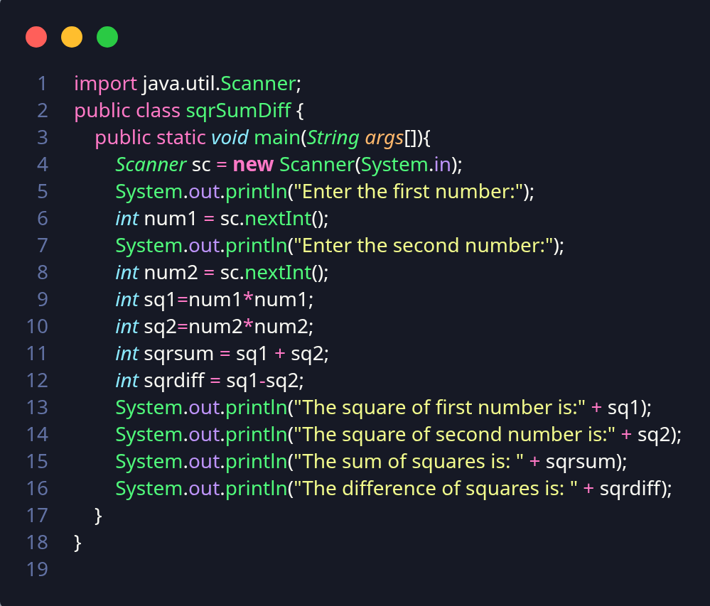

Sum, Average, Product, Smallest and Largest
- Write a program that inputs 3 integers from users and displays the sum, average, product, the smallest and the largest of numbers.
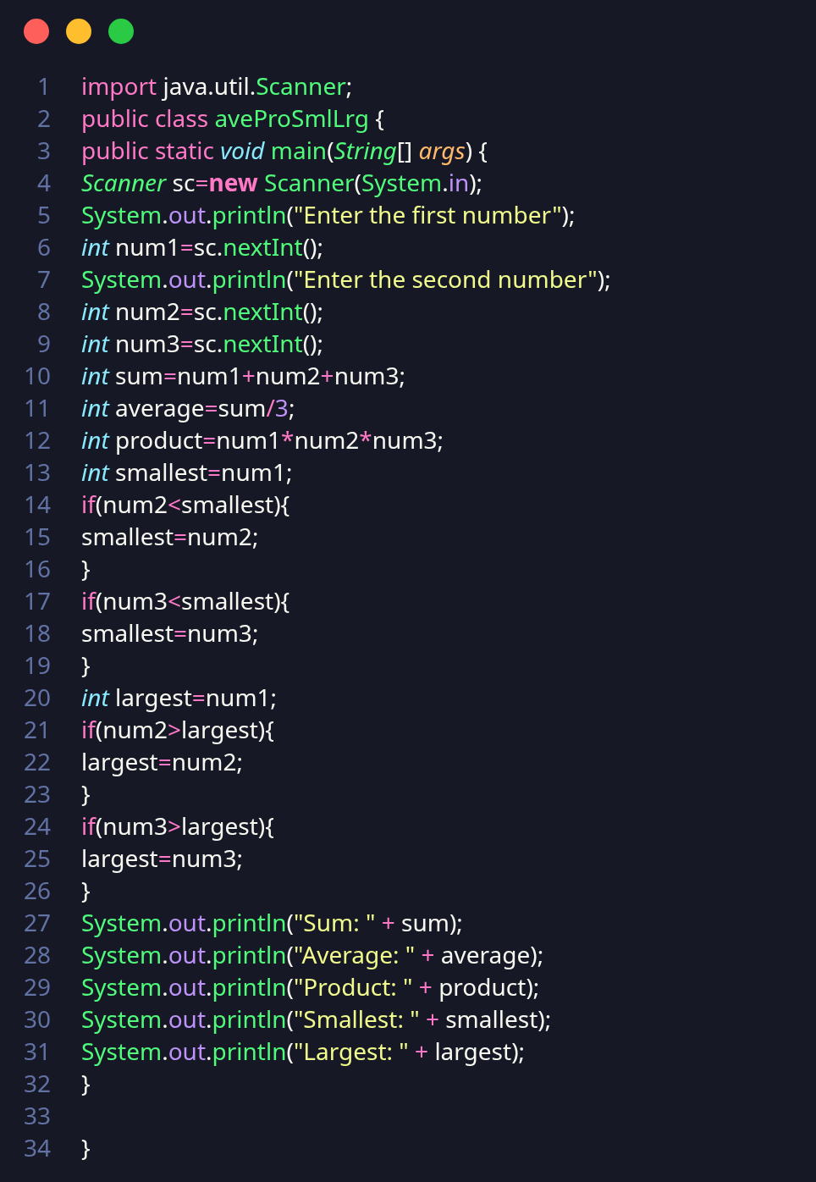

Check if Number and its Square is Greater Than, Equal To or Lesser than 1000
- Write a programs that takes one integer from user an an input and displays whether the number and its square are greater than, equal to or lesser than 1000.
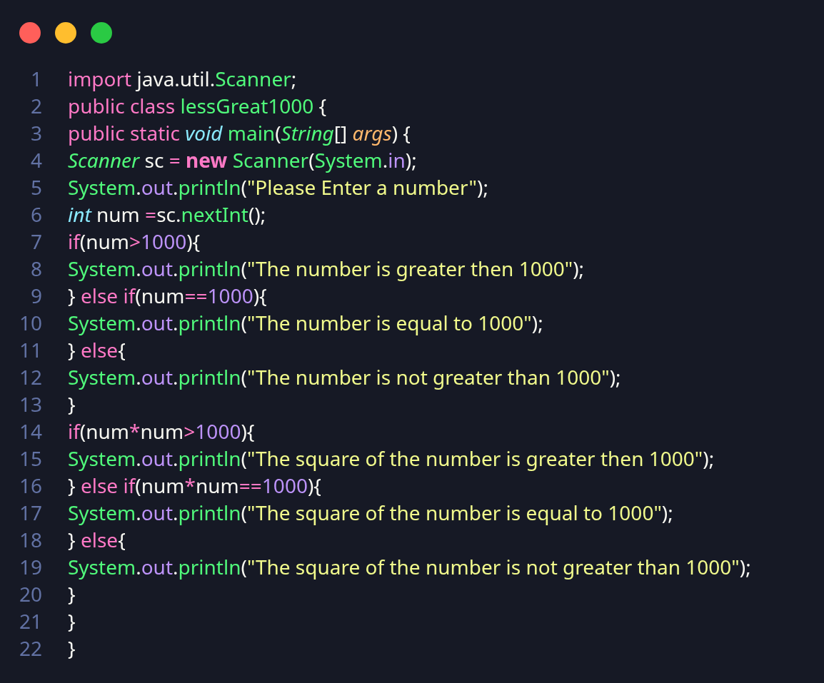

Lab 2

Check Positive
- Write a Java program that takes an integer input from the user and prints a message only if the number is positive.
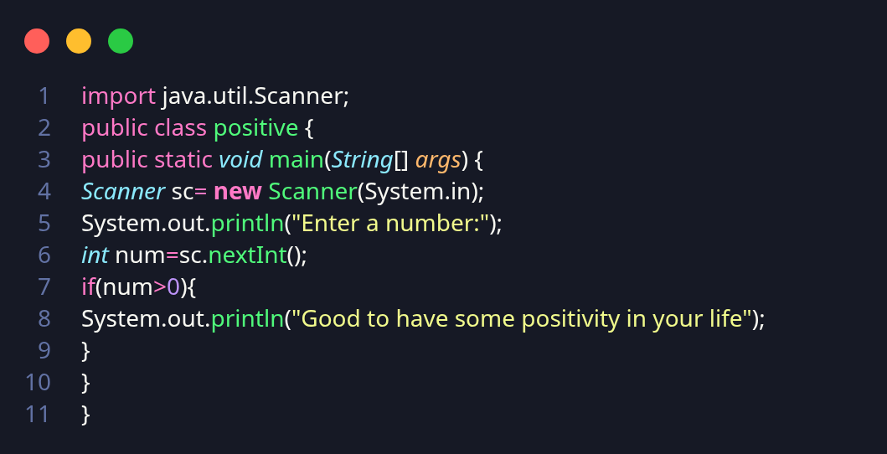

Pass Check
- Write a Java program that takes marks as input and prints "You passed the exam" only if marks are greater than or equal to 50
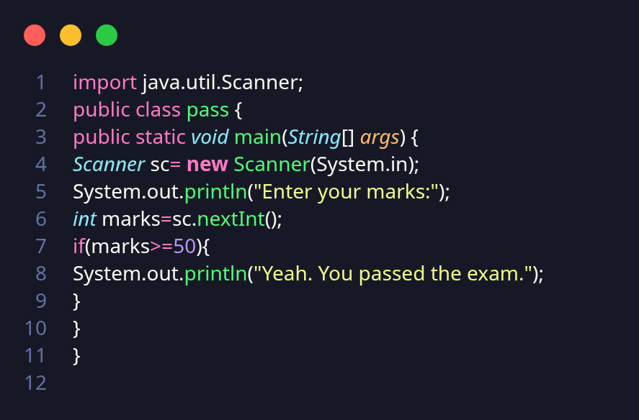

Check Even or Odd
- Write a Java program that takes an integer from the user and checks whether the number is even or odd.
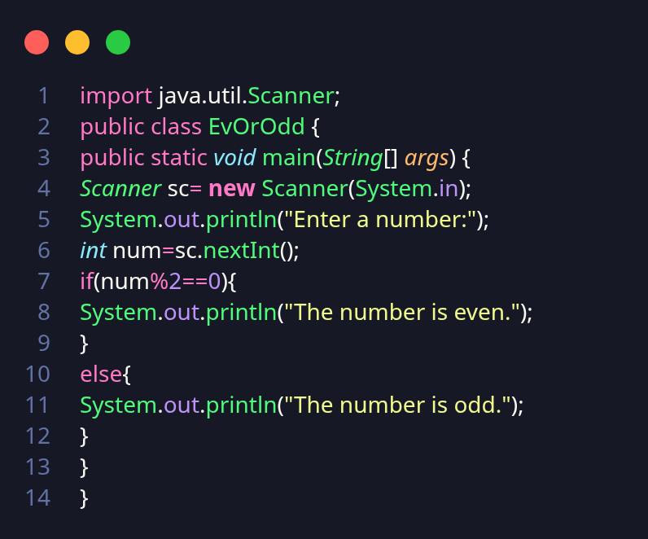

Check Leap Year
- Write a Java program that checks whether a given year is a leap year or not.
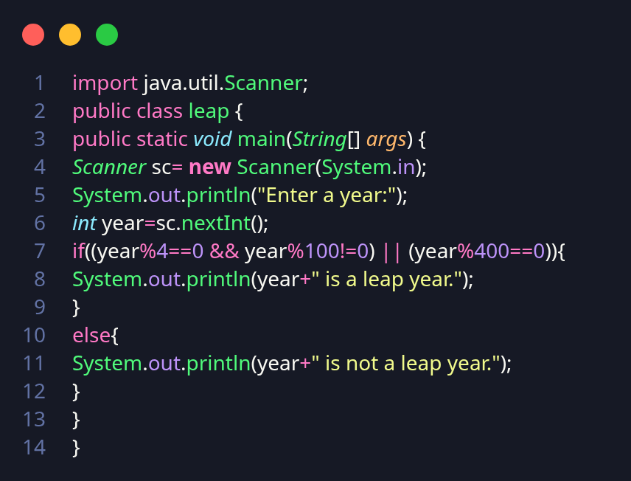

Calculate Electricity Bill
- Write a Java program to calculate electricity bill based on units consumed: If units ≤ 100 charge Rs. 5 per unit Otherwise → charge Rs. 10 per unit
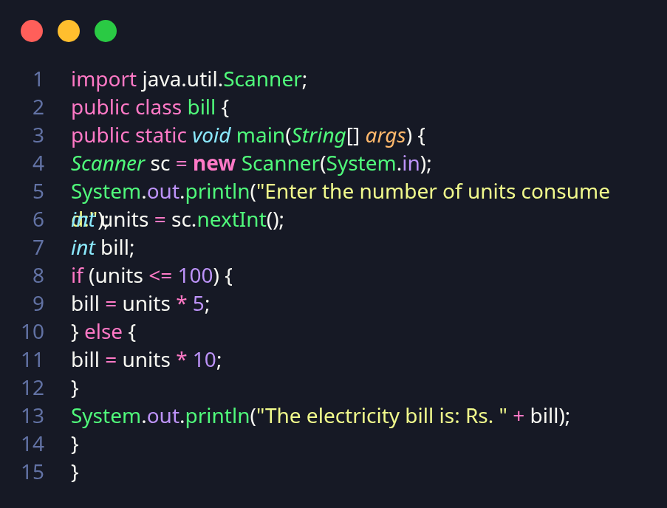

Check Largest Number
- Write a Java program that takes three numbers from the user and prints the largest number.
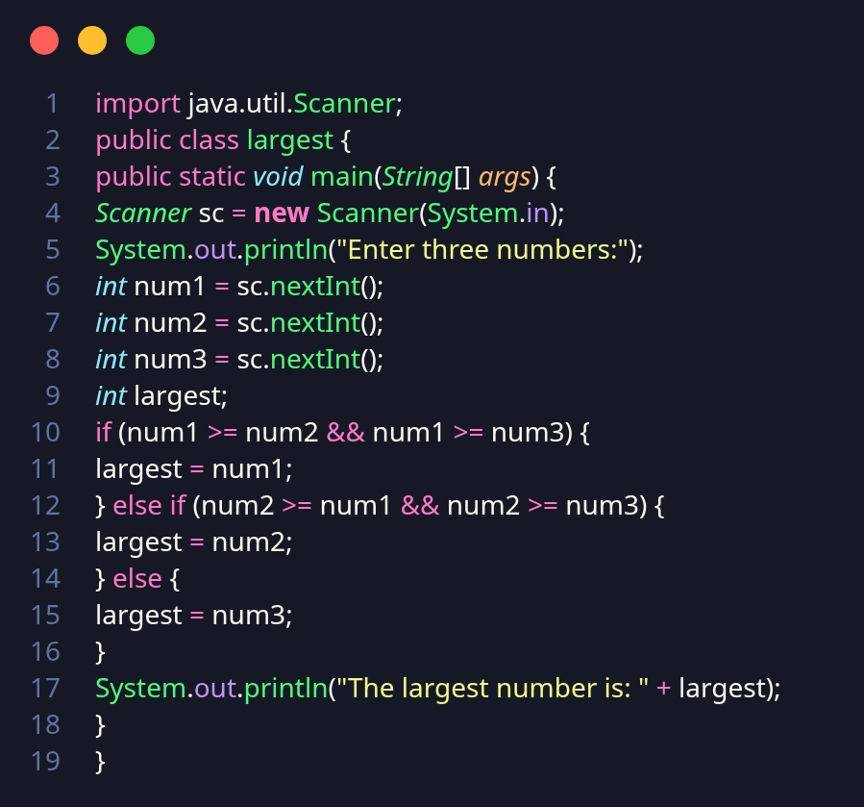

Print Grade
- Write a Java program that takes marks as input and prints the grade:
- Marks ≥ 90 → Grade A
- Marks ≥ 75 → Grade B
- Marks ≥ 50 → Grade C
- Marks < 50 → Grade F
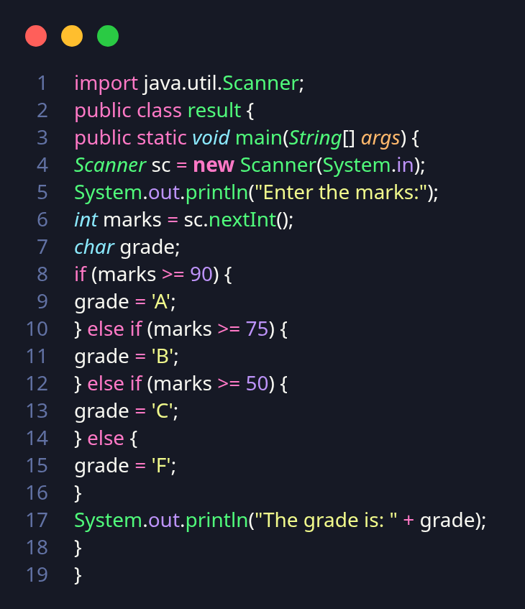

Check Leap Year (Specific Conditions)
- Write a Java program that takes a year as input and checks whether it is a leap year or not. A year divisible by 400 → Leap year. A year divisible by 100 but not 400 → Not a leap year. Otherwise → Not a leap year
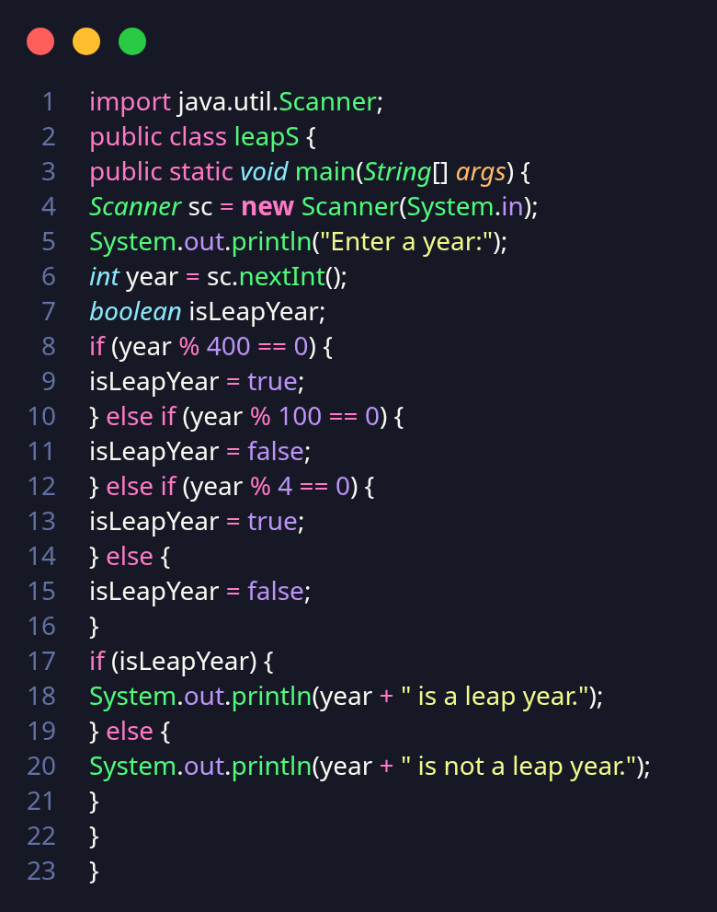

Check Vote Eligibility
- Write a Java program that asks the user for their age:
- Age < 18 → "Not eligible to vote"
- Age ≥ 18 → "Eligible to vote"
- If Age ≥ 60 → Also print "You are a senior citizen

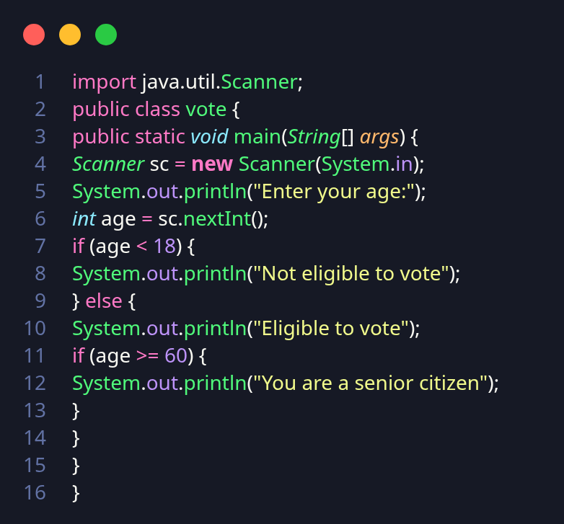

Perform Arithmetic Operations
- Write a Java program that takes two numbers and an operator (+, -, *, /) as input and performs the operation using a switch statement.
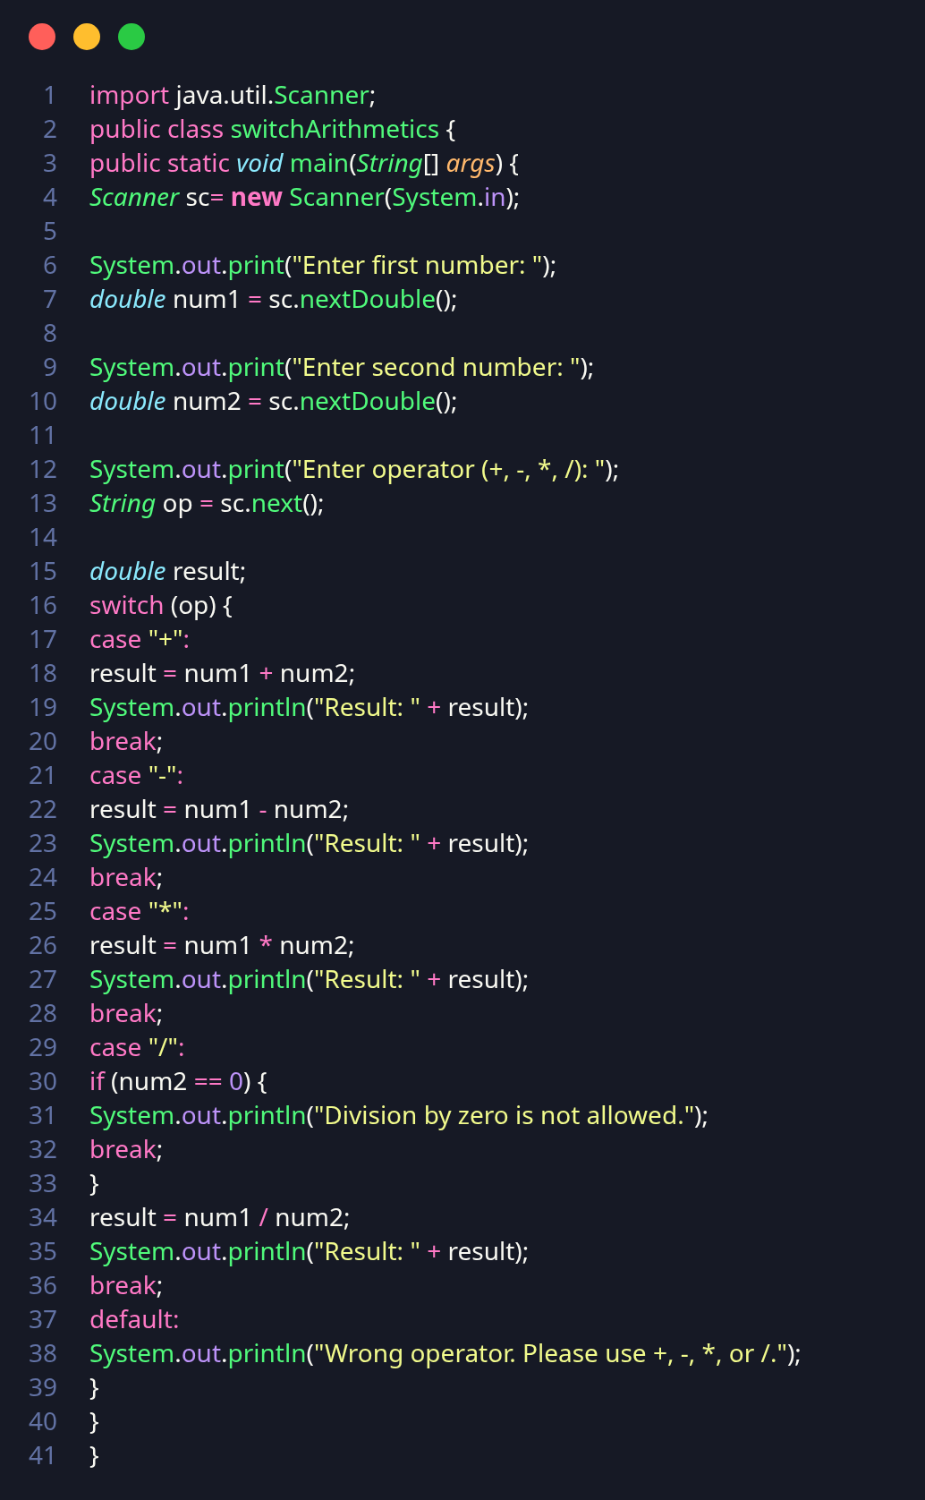

Days in a Month
- Write a Java program that takes a month number (1–12) as input and prints the number of days in that month. For February, assume 28 days.
